TITLE: SUBTITLE

Attention:
When you submit the paper remember to include all authors and the required metadata in the website of the journal, otherwise they can not be added later.

Fill author name ONLY for the LAST VERSION of your paper.

Endnotes Footnotes and annexes

The use of endnotes, footnotes and annexes is not allowed in JOTSE
Horizontal pages
The use of horizontal pages is not allowed in JOTSE

Abstract: [Text length should not exceed 250 words.] (Required field)
Keywords (minimum 3 and maximum 6 words).
Introduction: [Text Body] (Required field)
Design/methodology/approach: [Text Body] (Required field)
Conclusions: [Text Body] (Required field)
References: [Text Body] (Required field)
1. Main headings (Level 1) (Calibri 12)
[Text Body] (Calibri 10)

  - Second-level headings (Calibri 12)
[Text Body] (Calibri 10)

Third-level headings (Calibri 12)
[Text Body] (Calibri 10)

Table:
bold italic, 10 pt | bold italic, 10 pt | bold italic, 10 pt | bold italic, 10 pt | bold italic, 10 pt
Italic, 10 pt | Normal 10 pt
Italic, 10 pt |  | 10 pt | 10 pt
Italic, 10 pt |  |  |  | 10 pt
Table 1. Information about table 1
Figures:
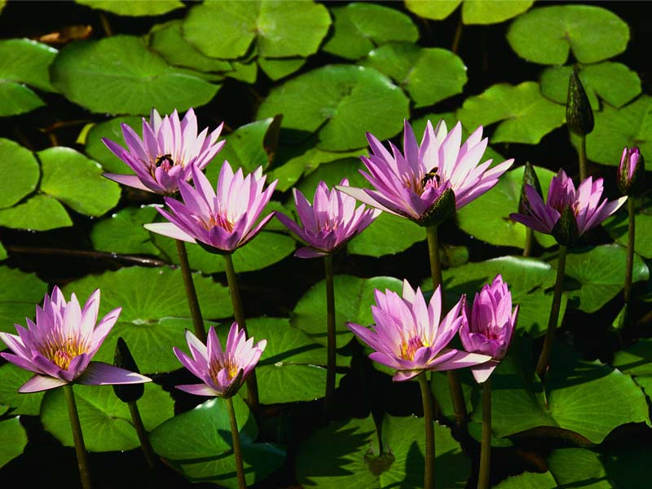
Figure 1. Legend content

Declaration of Conflicting Interests
The author(s) declared no potential conflicts of interest with respect to the research, authorship, and/or publication of this article.
Note: if there is some conflicting interest, please detail it.

Funding
The author(s) received no financial support for the research, authorship, and/or publication of this article.
Note: if the author(s) received financial support, please detail it.

References
Please write cites in text using the last edition of APA style. Here, you can find the most important rules; however, you can find the complete rules in the American Psychological Association (http://www.apa.org/).
Examples:
Marin-Garcia Juan A. & Lloret J. (2011). Industrial Engineering Higher Education in the European Area (EHEA). Journal of Industrial Engineering and Management, 4(1), 1-12.
Kim, H.N. (2008). The phenomenon of blogs and theoretical model of blog use in educational contexts. Computers & Education, 51(3), 1342-1352. doi:10.1016/j.compedu.2007.12.005
Lederman, R., Shanks, G., & Gibbs, M.R. (2003, June). Meeting privacy obligations: the implications for information systems development. Proceedings of the 11th European Conference on Information Systems. Paper presented at ECIS: Naples, Italy. Retrieved June 29th, 2009, from: http://is2.lse.ac.uk/asp/aspecis/20030081.pdf
Yániz, C., & Villardón, L. (2006). Planificar desde competencias para promover el aprendizaje. Bilbao: Mensajero
IES Institute for Environment and Sustainability. (2009). ILCD supporting tools. Retrieved from http://lct.jrc.ec.europa.eu/assessment/tools

How to reference in the text?
A work by one author: Name the author in the signal phrase or in the parentheses each time you cite the work.
e.g.: Research by Amante (2011) showed...
e.g.: (Amante, 2011)
A work by two authors: Name both authors in the signal phrase or in the parentheses each time you cite the work.
e.g.: Research by Wegener and Petty (1994) showed...
e.g.: (Wegener & Petty, 1994)
A work by three to five Authors: List all the authors in the signal phrase or in the parentheses first time you cite the source:
e.g.: Research by Amante, Martinez, Cadenato, Gallego and Salan (2011) showed…
e.g.: (Amante, Martínez, Cadenato, Gallego & Salan, 1993)

In subsequent citations, only use the first author's last name followed by "et al."
e.g.: Research by Kernis et al. (1993) showed …
e.g.: (Kernis et al., 1993)
Six or more authors: Use the first author's name followed by et al.
e.g.: Research by Martínez et al. (2010) showed …
e.g.: (Martínez et al., 2010)
Unknown Author: If the work does not have an author, cite the source by its title in the signal phrase or use the first word or two in the parentheses. Titles of books and reports are italicized or underlined; titles of articles and chapters are in quotation marks.
Two or more works in the same parentheses: When your parenthetical citation includes two or more works, order them the same way they appear in the reference list, separated by a semi-colon.
e.g.: (Berndt, 2002; Harlow, 1983)
Two or more works by the same author in the same year: If you have two sources by the same author in the same year, use lower-case letters (a, b, c) with the year to order the entries in the reference list. Use the lower-case letters with the year in the in-text citation.
e.g.: Research by Berndt (1981a) illustrated that...

